Business Template
HOTEL DATABASE
Logo / Image

CONTENTS
1 BUSINESS DESCRIPTION ............................................................... 3
1.1 Business background ........................................................ 3
1.2 Problems. Current Situation ................................................. 3
1.3 The benefits of implementing a database. Project Vision ..................... 3
2 MODEL DESCRIPTION ................................................................ 4
2.1 Definitions & Acronyms ..................................................... 4
2.2 Logical Scheme ............................................................. 4
2.3 Objects ..................................................................... 5

1 BUSINESS DESCRIPTION

1.1 BUSINESS BACKGROUND
The hotel industry operates a complex ecosystem requiring seamless management of rooms, guests, bookings, staff, payments, and ancillary services. With multiple room types, varied check-in schedules, and diverse service offerings, coordinating this infrastructure efficiently presents a significant challenge. Hotel management needs a robust database system capable of tracking detailed information about rooms, reservations, customers, staff activities, room service orders, and payments. The goal is to maintain accurate real-time information on hotel operations and ensure consistently high service quality.

1.2 PROBLEMS. CURRENT SITUATION
Currently, hotel management faces several issues:
- Lack of a centralized system for tracking room availability, bookings, and customer data.
- Manual check-in and check-out processes, leading to errors and delays.
- Disjointed management of room service orders and staff assignments.
- Inability to quickly access guest history or generate accurate financial reports.

Without a unified database, managing these processes is inefficient, error-prone, and costly.

1.3 THE BENEFITS OF IMPLEMENTING A DATABASE. PROJECT VISION
The implementation of a robust database system would:
- Centralize all hotel-related information, improving coordination across departments.
- Automate booking workflows, room assignment, and check-in/check-out tracking.
- Provide real-time data on room status, occupancy, and service requests, improving the guest experience.
- Streamline payment processing, ensuring quick transactions and accurate financial records.

This database project aims to improve overall operational efficiency, reduce costs, and deliver guests a reliable and polished hospitality experience.

2 MODEL DESCRIPTION

2.1 DEFINITIONS & ACRONYMS
PK – Primary Key, UNIQUE identifier for each record in a table.
FK – Foreign Key, a reference to a primary key in another table.
Hotel – A lodging establishment offering rooms and services to guests.
Room – A rentable unit within a hotel, classified by type.
Booking – A reservation made by a customer for one or more rooms.
Customer – A person who makes a reservation and stays at the hotel.
Staff – An employee of the hotel responsible for a given role.
Service – An additional offering (e.g., laundry, spa) billed to a booking.
Payment – A financial transaction associated with a booking.

2.2 LOGICAL SCHEME
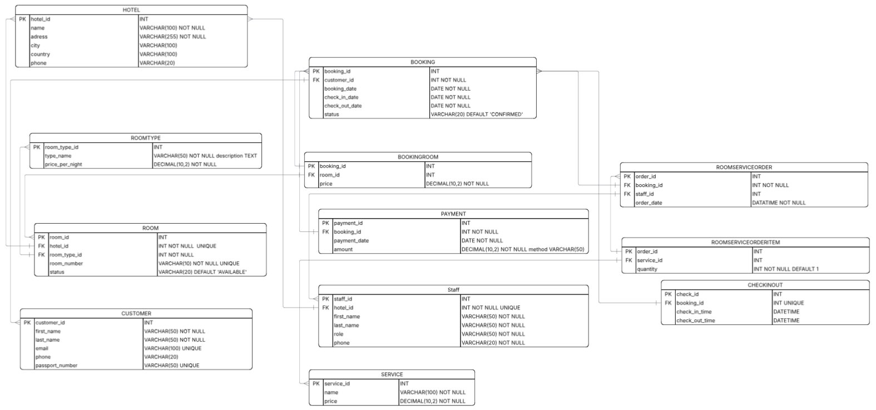

2.3 OBJECTS
In any type of relationship, the first one will be a table that describes. (one to many, one for the described table)

Table Description
Hotel table stores core information about each hotel property, including its name, address, city, country, and contact phone number.
Table Name | Field name | Field Description | Data Type
Hotel | hotel_id | Identifier, PK | INT
 | name | Hotel name, NOT NULL | VARCHAR(100)
 | address | Street address, NOT NULL | VARCHAR(255)
 | city | City of the hotel | VARCHAR(100)
 | country | Country of the hotel | VARCHAR(100)
 | phone | Contact phone number | VARCHAR(20)
Relationships
Room (one-to-many), Staff (one-to-many)
Example with data
hotel_id | name | address | city | country | phone
1 | Grand Plaza | Abay 10 | Almaty | Kazakhstan | +7 727 000 0001
2 | City Inn | Seyfullina 5 | Astana | Kazakhstan | +7 717 000 0002

Table Description
RoomType table defines categories of rooms available in the hotel, including a description and the nightly rate.
Table Name | Field name | Field Description | Data Type
RoomType | room_type_id | Identifier, PK | INT
 | type_name | Name of room type, NOT NULL | VARCHAR(50)
 | description | Description of the room type | TEXT
 | price_per_night | Nightly rate, NOT NULL | DECIMAL(10,2)
Relationships
Room (one-to-many)
Example with data
room_type_id | type_name | price_per_night
1 | Standard | 50.00
2 | Deluxe | 120.00
3 | Suite | 250.00

Table Description
Room table contains details of each individual room, linking it to a hotel and a room type, with its room number and current availability status.
Table Name | Field name | Field Description | Data Type
Room | room_id | Identifier, PK | INT
 | hotel_id | Reference to hotel, FK, NOT NULL, UNIQUE | INT
 | room_type_id | Reference to room type, FK, NOT NULL | INT
 | room_number | Room number, NOT NULL, UNIQUE | VARCHAR(10)
 | status | Availability status, DEFAULT 'AVAILABLE' | VARCHAR(20)
Relationships
Hotel (many-to-one), RoomType (many-to-one), BookingRoom (one-to-many)
Example with data
room_id | hotel_id | room_type_id | room_number | status
1 | 1 | 1 | 101 | AVAILABLE
2 | 1 | 2 | 201 | OCCUPIED
3 | 2 | 3 | 301 | AVAILABLE

Table Description
Customer table stores personal and contact information for each guest, including a unique email and passport number for identification.
Table Name | Field name | Field Description | Data Type
Customer | customer_id | Identifier, PK | INT
 | first_name | First name, NOT NULL | VARCHAR(50)
 | last_name | Last name, NOT NULL | VARCHAR(50)
 | email | Email address, UNIQUE | VARCHAR(100)
 | phone | Phone number | VARCHAR(20)
 | passport_number | Passport number, UNIQUE | VARCHAR(50)
Relationships
Booking (one-to-many)
Example with data
customer_id | first_name | last_name | email | passport_number
1 | Dias | Yermekov | dias@example.com | KZ001122334
2 | Aisha | Bekova | aisha@example.com | KZ004455667

Table Description
Booking table records every reservation made by a customer, capturing the booking date, planned check-in and check-out dates, and current status.
Table Name | Field name | Field Description | Data Type
Booking | booking_id | Identifier, PK | INT
 | customer_id | Reference to customer, FK, NOT NULL | INT NOT NULL
 | booking_date | Date the booking was created, NOT NULL | DATE NOT NULL
 | check_in_date | Planned check-in date, NOT NULL | DATE NOT NULL
 | check_out_date | Planned check-out date, NOT NULL | DATE NOT NULL
 | status | Booking status, DEFAULT 'CONFIRMED' | VARCHAR(20)
Relationships
Customer (many-to-one), BookingRoom (one-to-many), Payment (one-to-many), RoomServiceOrder (one-to-many), Checkinout (one-to-one)
Example with data
booking_id | customer_id | booking_date | check_in_date | check_out_date | status
1 | 1 | 2024-11-01 | 2024-11-08 | 2024-11-10 | CONFIRMED
2 | 2 | 2024-11-03 | 2024-11-09 | 2024-11-12 | CONFIRMED

Table Description
BookingRoom is a junction table that links bookings to specific rooms, recording the price agreed for that room at the time of booking.
Table Name | Field name | Field Description | Data Type
BookingRoom | booking_id | Reference to booking, PK/FK | INT
 | room_id | Reference to room, PK/FK | INT
 | price | Price for the room in this booking, NOT NULL | DECIMAL(10,2)
Relationships
Booking (many-to-one), Room (many-to-one)
Example with data
booking_id | room_id | price
1 | 1 | 50.00
1 | 2 | 120.00
2 | 3 | 250.00

Table Description
Payment table records all financial transactions related to a booking, including the payment date, amount, and payment method used.
Table Name | Field name | Field Description | Data Type
Payment | payment_id | Identifier, PK | INT
 | booking_id | Reference to booking, FK, NOT NULL | INT NOT NULL
 | payment_date | Date of payment, NOT NULL | DATE NOT NULL
 | amount | Amount paid, NOT NULL | DECIMAL(10,2)
 | method | Payment method (e.g. Card, Cash) | VARCHAR(50)
Relationships
Booking (many-to-one)
Example with data
payment_id | booking_id | payment_date | amount | method
1 | 1 | 2024-11-08 | 170.00 | Card
2 | 2 | 2024-11-09 | 250.00 | Cash

Table Description
Staff table stores employee details for each hotel, including their name, role, and contact phone. Each staff member is linked to a specific hotel and must have a unique assignment within it.
Table Name | Field name | Field Description | Data Type
Staff | staff_id | Identifier, PK | INT
 | hotel_id | Reference to hotel, FK, NOT NULL, UNIQUE | INT NOT NULL
 | first_name | First name, NOT NULL | VARCHAR(50)
 | last_name | Last name, NOT NULL | VARCHAR(50)
 | role | Employee role, NOT NULL | VARCHAR(50)
 | phone | Contact phone, NOT NULL | VARCHAR(20)
Relationships
Hotel (many-to-one), RoomServiceOrder (one-to-many)
Example with data
staff_id | hotel_id | first_name | last_name | role
1 | 1 | Aziz | Abikenov | Manager
2 | 1 | Maira | Aslanova | Receptionist
3 | 2 | Lucas | Thomas | Housekeeping

Table Description
Service table defines the catalog of additional services offered by the hotel (e.g., laundry, spa, airport transfer), each with a fixed price.
Table Name | Field name | Field Description | Data Type
Service | service_id | Identifier, PK | INT
 | name | Service name, NOT NULL | VARCHAR(100)
 | price | Service price, NOT NULL | DECIMAL(10,2)
Relationships
RoomServiceOrderItem (one-to-many)
Example with data
service_id | name | price
1 | Laundry | 15.00
2 | Spa Treatment | 80.00
3 | Airport Transfer | 35.00

Table Description
RoomServiceOrder table records each service request submitted during a booking, capturing which staff member handled it and the date/time of the order.
Table Name | Field name | Field Description | Data Type
RoomServiceOrder | order_id | Identifier, PK | INT
 | booking_id | Reference to booking, FK, NOT NULL | INT NOT NULL
 | staff_id | Reference to staff member, FK | INT
 | order_date | Date and time of order, NOT NULL | DATETIME NOT NULL
Relationships
Booking (many-to-one), Staff (many-to-one), RoomServiceOrderItem (one-to-many)
Example with data
order_id | booking_id | staff_id | order_date
1 | 1 | 2 | 2024-11-08 10:00
2 | 2 | 3 | 2024-11-09 14:30

Table Description
RoomServiceOrderItem is a junction table linking each room service order to specific services, along with the quantity ordered. Quantity defaults to 1 if not specified.
Table Name | Field name | Field Description | Data Type
RoomServiceOrderItem | order_id | Reference to order, PK/FK | INT
 | service_id | Reference to service, PK/FK | INT
 | quantity | Quantity ordered, NOT NULL, DEFAULT 1 | INT
Relationships
RoomServiceOrder (many-to-one), Service (many-to-one)
Example with data
order_id | service_id | quantity
1 | 1 | 2
1 | 3 | 1
2 | 2 | 1

Table Description
CheckInOut table tracks the actual check-in and check-out timestamps for each booking, providing an audit record of guest arrivals and departures. Each booking has exactly one check-in/out record.
Table Name | Field name | Field Description | Data Type
CheckInOut | check_id | Identifier, PK | INT
 | booking_id | Reference to booking, FK, UNIQUE | INT UNIQUE
 | check_in_time | Actual check-in date and time | DATETIME
 | check_out_time | Actual check-out date and time | DATETIME
Relationships
Booking (one-to-one)
Example with data
check_id | booking_id | check_in_time | check_out_time
1 | 1 | 2024-11-08 14:00 | 2024-11-10 11:00
2 | 2 | 2024-11-09 15:30 | NULL

